# Setting up the Configuration Recorder

1. Logging in to the Amazon Web Console.

### Introduction

To begin using AWS Config, you must first set up the configuration recorder. You tell the configuration recorder what resource configurations to record and where to record configuration items (CIs) in AWS Simple Storage Service (S3) and through AWS Simple Notification Service (SNS). This lab won't focus on S3 or SNS, but it is a requirement to set up an S3 bucket to use AWS Config. AWS Config also uses an Identity and Access Management (IAM) role to enable the service to record configurations. The Cloud Academy lab setup process created this role for you.

### Instructions

1. In the AWS Management Console search bar, enter *Config*, and click the **Config** result under **Services**:

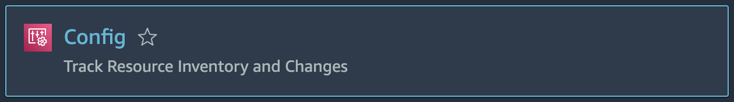

2. Click on **Get Started** when presented with the AWS Config welcome page:

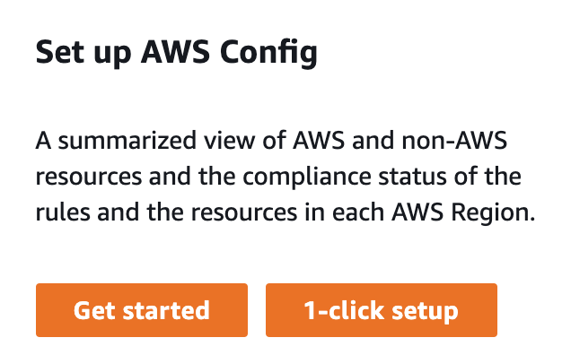

This will directly take to you to the configuration recorder setup form.

3. Enter the following commands into the **Settings** form:

* **Resource types to record**
  + **Record all resources supported in this region**: Checked
* **AWS Config role**
  + **Choose a role from your account**: Selected
  + **Role name**: config-role-us-west-2
* **Amazon S3 bucket**
  + **Create a bucket**: Selected
  + **Bucket name**: Leave the default value (it will be something like config-bucket-123456789012, changing this will mean you won't have access to the created bucket)
* **Amazon SNS**
  + **Stream configuration changes and notifications to an Amazon SNS topic**: Unchecked

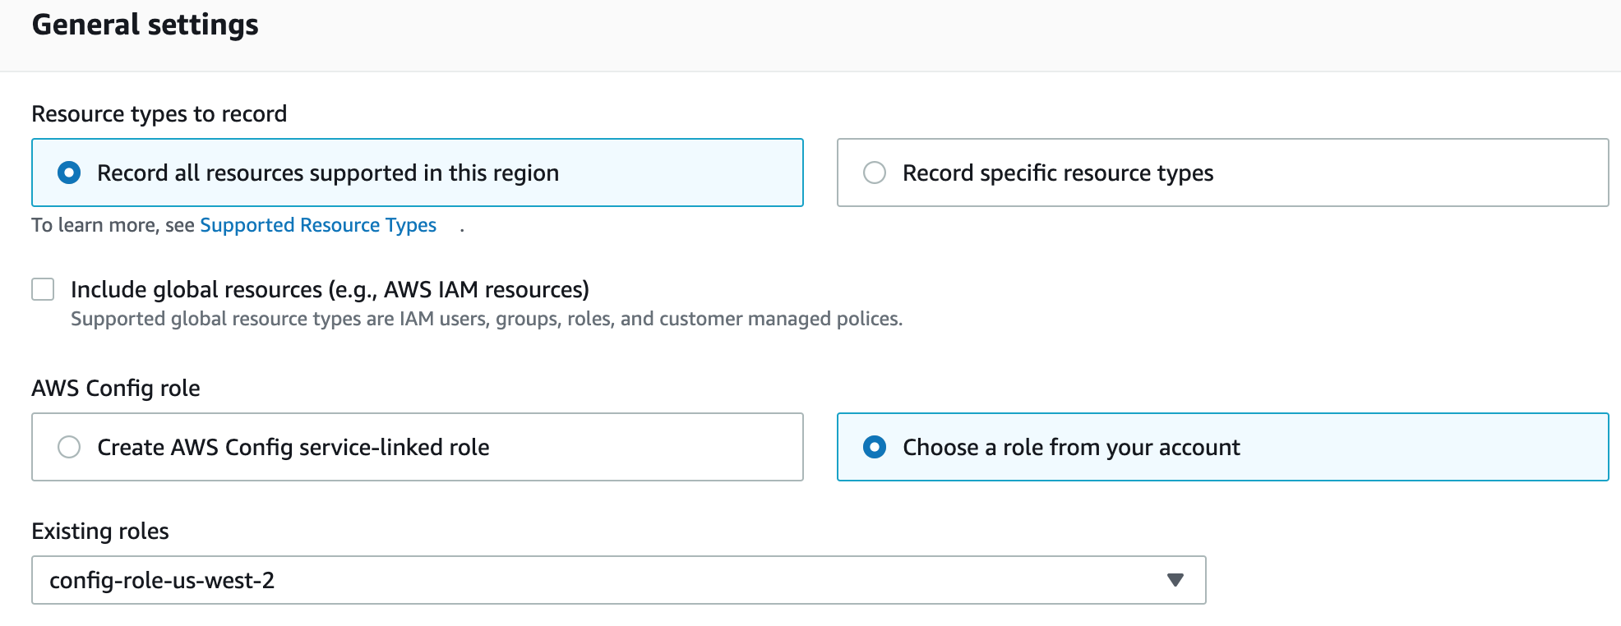

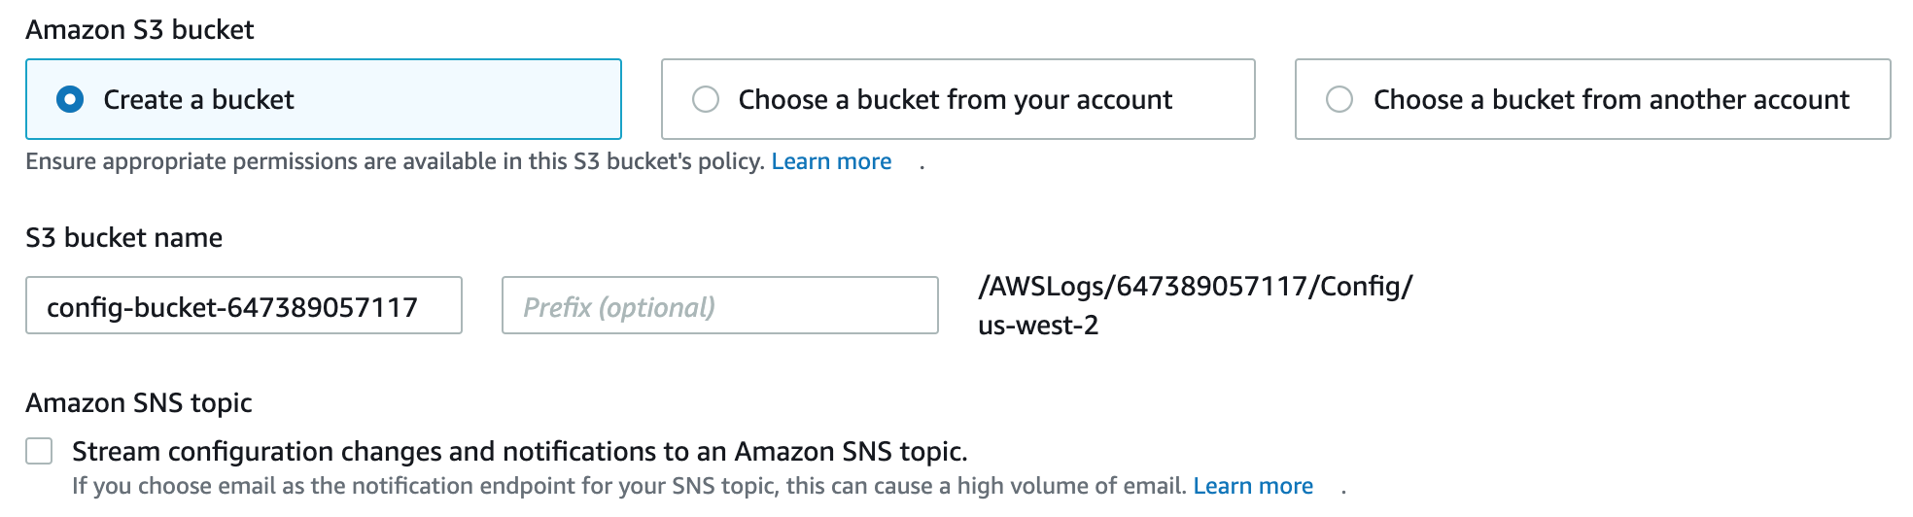

4. Once you have verified the values are correct, click **Next**.

5. In the **Rules** step, click **Next** at the bottom right of the page.

You will go through the AWS managed rules in a future lab step. There are more managed rules available after you initialize the configuration recorder than there are available now, before it is initialized.

6. In the **Review** step, verify there are 0 **Config rules**and **All resources (excluding global resources)** appears:

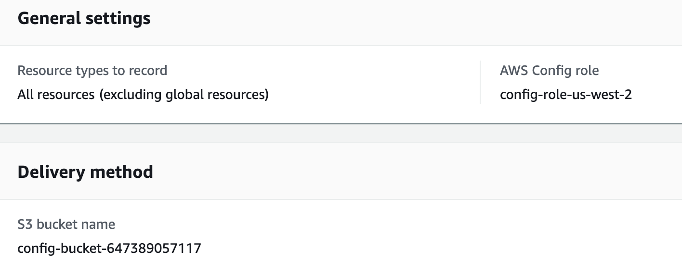

7. Click **Confirm**to start the configuration recorder.

### Summary

In this lab step, you configured the configuration recorder to record all resource configurations in the us-west-2 region. You created an S3 bucket to store AWS Config history files and snapshots.

VALIDATION CHECKS

**1Checks**

Check again

**The Configuration Recorder Has been Set Up**

Check that the configuration recorder has been created

AWS Config